|  |  |  |  |  |  |
| --- | --- | --- | --- | --- | --- |
| Date | 12-Dec-22 | | | Tester Name | Janette Paus |
| Environment | Penfax - Test 2 | | | Login used | <If different from the Tester> |
| Operating System | Windows | Version: 21H2 | Update Number: | | |
| Software Used | Select Software | Version: 107.0.1418.56 | Update Number: | | |
| Select Software | Version: | Update Number: | | |
| Application Release version | R22.4.1 | | | | |
| Test Case Title | E13.03 | | | | |
| Test Type | Regression | | | | |
| Test Scenario | Add a trustee for a PEPP Beneficiary | | | | |
| Expected Results | The new PEPP beneficiary is added correctly and is reflected in PENWEB. | | | | |
| Pass/Fail | Pass | | | JIRA# |  |

Search for any PEPP member that do not have trustee beneficiary listed yet. (If trustee is already there as beneficiary then new trustee will be added as beneficiary creating two trustees as beneficiary on the person profile)

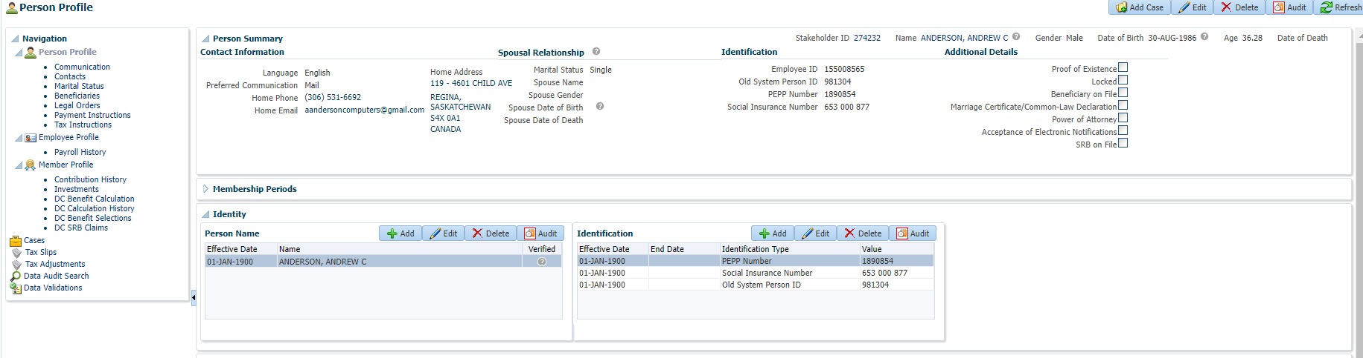

Open that member profile, Under person profile🡪 Beneficiary🡪 Beneficiary Designations

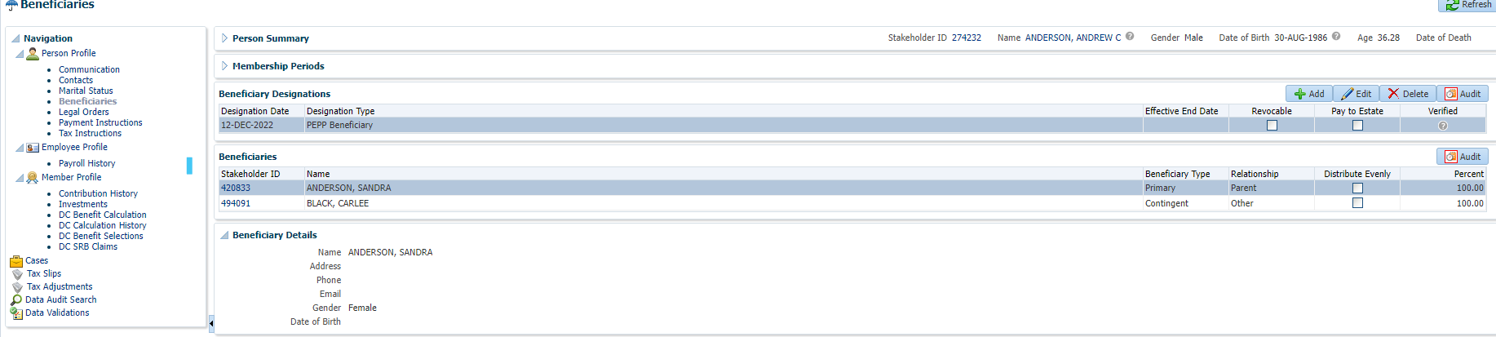

Add beneficiary designation 🡪 click Edit

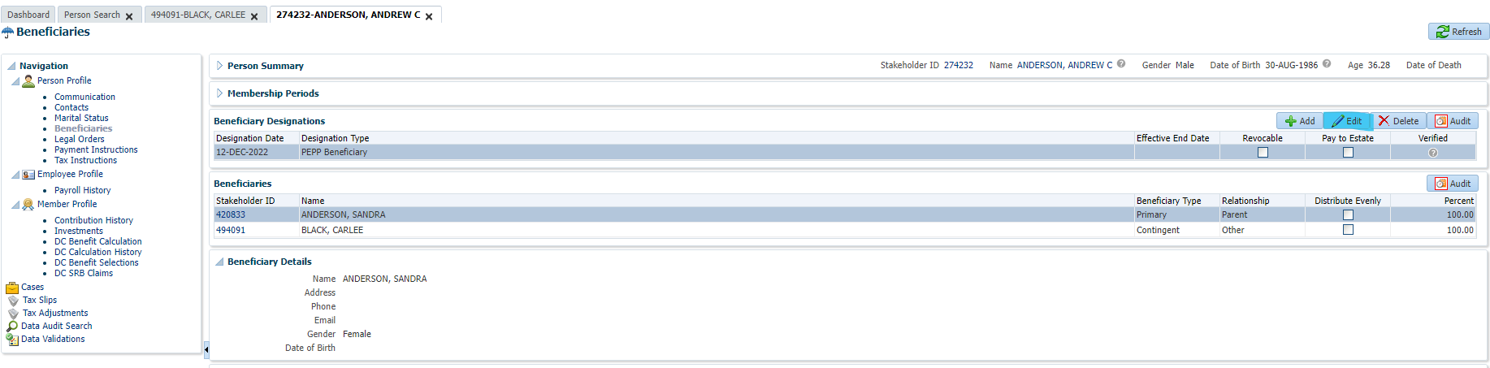

Click Add

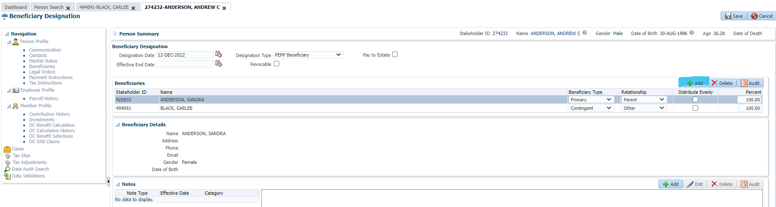

Add beneficiary details or search for beneficiary

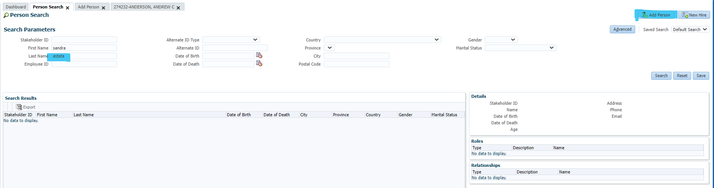

Here, new beneficiary details are added and then save the details.

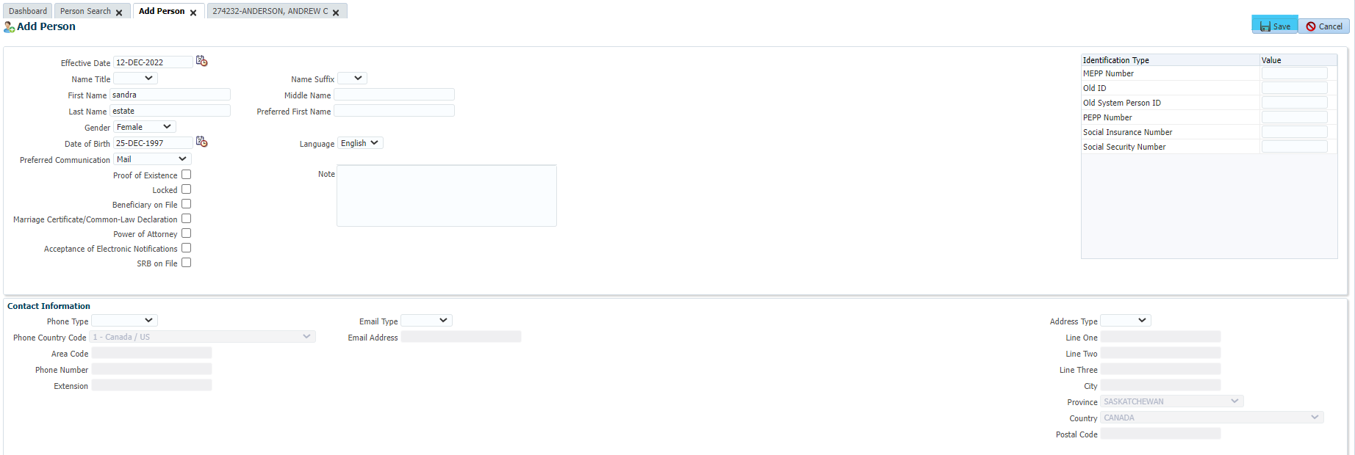

Add Beneficiary Type🡪 Trustee and Relationship and then save the details.

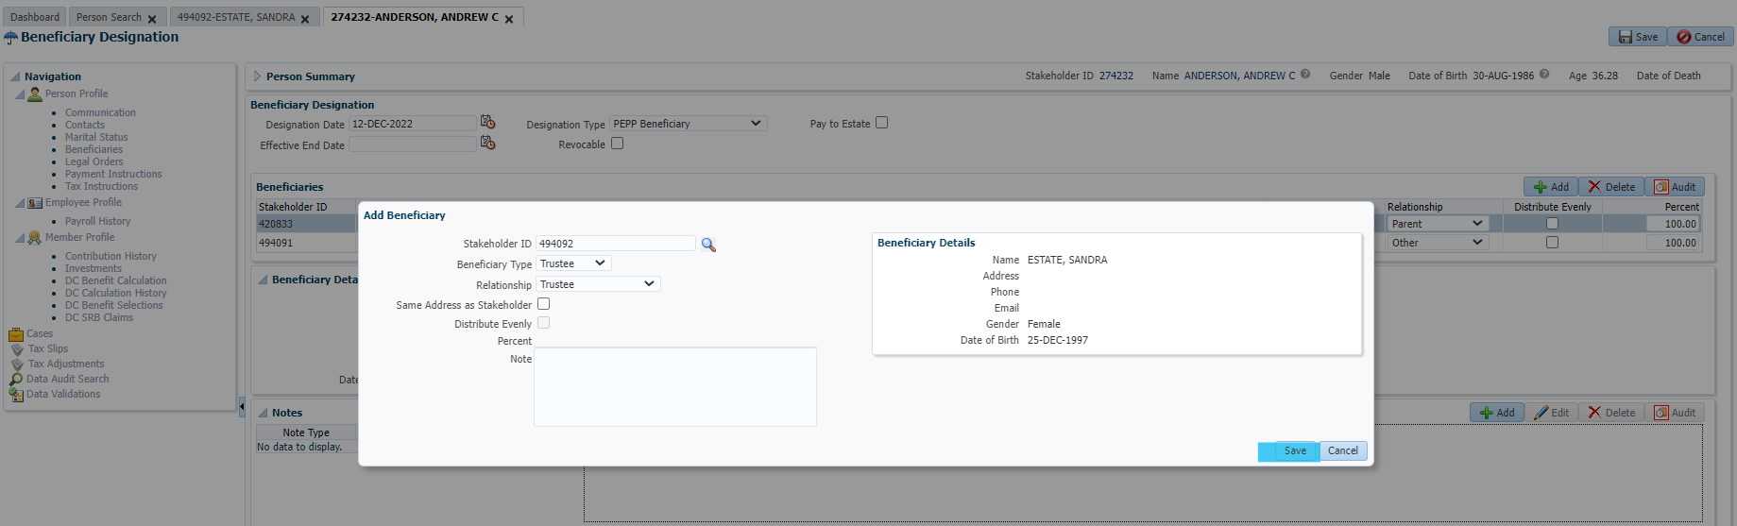

Enter Designation Date, Designation Type and hit save button at the top right corner.

New Contingent beneficiary is added

